**Barley Sheaf’s 20th Annual**

**FAMILY PICTO NIGHT & BASKET RAFFLE**

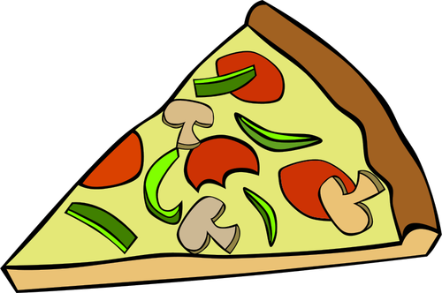**Friday, March 28, 202****5**

6:00 pm DOORS OPEN

6:45 pm PICTO begins

**Pre-order a large 16’’ plain pizza** $18 (from Al Fresco’s)

**SLICES OF PIZZA, DRINKS, SNACKS**- CASH ONLY!

**BAKE SALE**- CASH ONLY! **50/50**- CASH ONLY

**RAFFLE BASKETS**- Teacher Experiences, Themed Baskets, and local business baskets

Stay tuned for pictures in the coming weeks! (CASH OR CHECK!)

***All children must be accompanied by an adult AND SUPERVISED!***

**\*EVERY person attending MUST buy a ticket- $5/ person ($20 max/ family)**

**\*NO tickets will be handed out in advance.\***

**\*There will be a registration table for check-in at the door.\***

**THIS EVENT IS EXPECTED TO SELL OUT!**

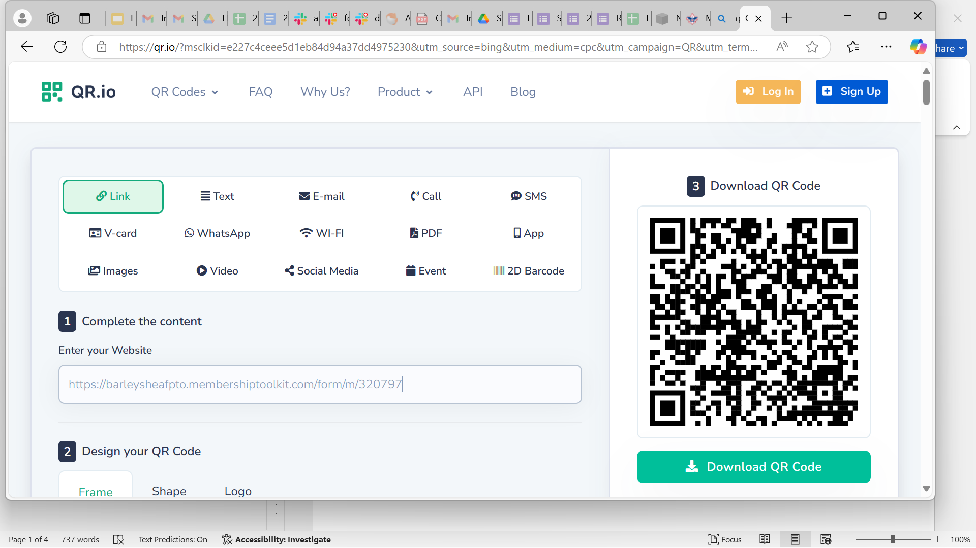**BUY YOUR TICKETS NOW!!!**

[**CLICK HERE TO REGISTER**](https://barleysheafpto.membershiptoolkit.com/form/m/320797)

**FAMILY PICTO NIGHT & BASKET RAFFLE- FAQs**

***What is PICTO?***

PICTO is picture BINGO for the whole family.

***What is the breakdown of the night?***

6:00 - 6:45 Cafeteria- pizza, drinks, treats

Gym area- purchase tickets, fill out tickets, put in for Raffle Baskets, local business baskets, & Teacher Experiences

6:45 PICTO Introduction in the gym

6:50 - 7:00 Game 1 (50/50 for sale in gym)

7:00 - 7:10 Game 2 (50/50 for sale in gym)

7:10 - 7:25 BREAK- Cafeteria- pizza, drinks, snacks

Gym area- last chance to purchase 50/50

7:25 50/50 winner announced + 50% of the basket & prizes winners will be announced, last chance to put your tickets for Baskets, Prizes

7:30 - 7:40 Game 3

7:40 - 7:50 Game 4

7:50 Remaining Basket & Prize Winners Announced

***Do I really need to pre-order a pizza?***

There is certainly no requirement to pre-order a pizza, however we only order a limited amount of extra pizza to avoid waste, so if pizza is “what’s for dinner” for your family that evening, pre-ordering is recommended. If you think a whole pizza is too much for your family, perhaps share the cost and the pizza with a friend.

***Can we bring our pizza/snacks into the gym?***

In order to keep all our Barley Bears safe, food is NOT PERMITTED in the gym.

***What are Teacher Experiences?***

Teacher Experiences are unique prizes donated by various Barley Sheaf staff for raffle, for example: a pizza lunch with a teacher, librarian for a day, kickball with friends…the teachers come up with the most creative ideas!. These prizes are truly priceless and the children love to see what their favorite teachers have offered for winning, so be prepared to be persuaded to buy some chances!

***Can a family win more than one basket, teacher experience, or prize?***

Yes! The raffle is all about luck. Not every family will win! Explaining this to your child ahead of time may be helpful. Helpful tip re: the basket/prize raffle tickets: bring some of your home address labels to affix to the tickets, so you don’t have to write your name repeatedly!

***Do I need to be present when the winners of the 50/50, Baskets, Teacher Experiences, and Prizes are announced?***

Should you be the lucky **50/50 prize winner, you MUST be present** to accept the prize, announced approximately 7:25 pm.

You **do not need** to be present when the Basket, Teacher Experiences and other Prize winners are announced (around 7:50 pm). If you are one of the lucky winners of a Basket, Experience or Prize and you are not present at the announcement, we will notify you and keep the winnings safe until you can pick it up (please be sure your name is neatly written on your tickets (or use address labels!)!

***I’d love to help out for a little, but also want to spend time with my family during PICTO, is this possible?***

Absolutely! Please look for a Sign-up Genius link coming out in the next few weeks. Your help is GREATLY APPRECIATED! Many hands make light work!

Class Basket List



|  |
| --- |
| A yellow sun with flames  Description automatically generatedAmazing Accessories  Be Craftful  Camp Out  Disney Magic  Extra! Extra! Read All About It  A chocolate bar with white stripes  Description automatically generatedFamily Game Night  Fidget Fun  Full of Pastabilities  LEGO Madness-LEGO Friends  Let Them Eat Cake (Baking)  Let’s Get Artsy  Art craft supplies photo album t and clip art - WikiClipArtMad Science  Mayhem Makers (Nerf/Laser Tag)  Pokemonapalooza  Queen for A Day  Sideline Superstars  (Sports Mom/Dad Essentials)  Stop, Camera, Action (Movie Night) |

**TICKET PRICES FOR RAFFLE BASKETS**

**\*class themed baskets\***

**\*teacher experiences\***

**AND MORE!!**

|  |
| --- |
| **$1 each**  **12 for $10**  **30 for $25**  **75 for $60**  **100 for $75** |

**CASH OR CHECK ONLY!**

**AVAILABLE FOR PURCHASE AT THE EVENT ONLY!**